Name: Patel Aayush Yogeshkumar

Roll no: - B-064

Enrollment no: - 2201030400075

Batch – B-2

Sem -4th

Subject - WT

Assignment -1

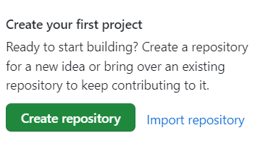

Creating a repository name as my enrolment number 2201030400075 , with public status.

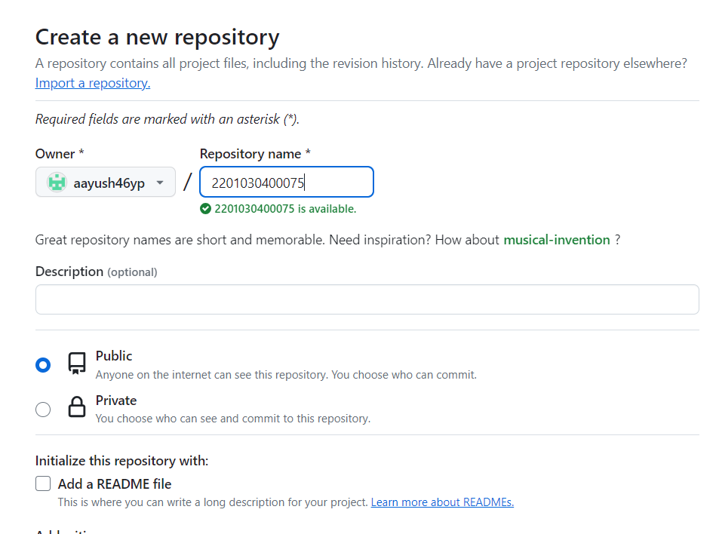

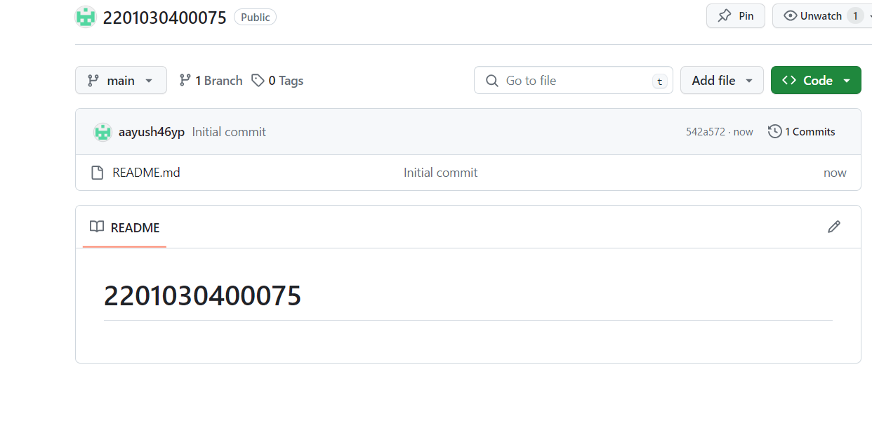

Created Repository .

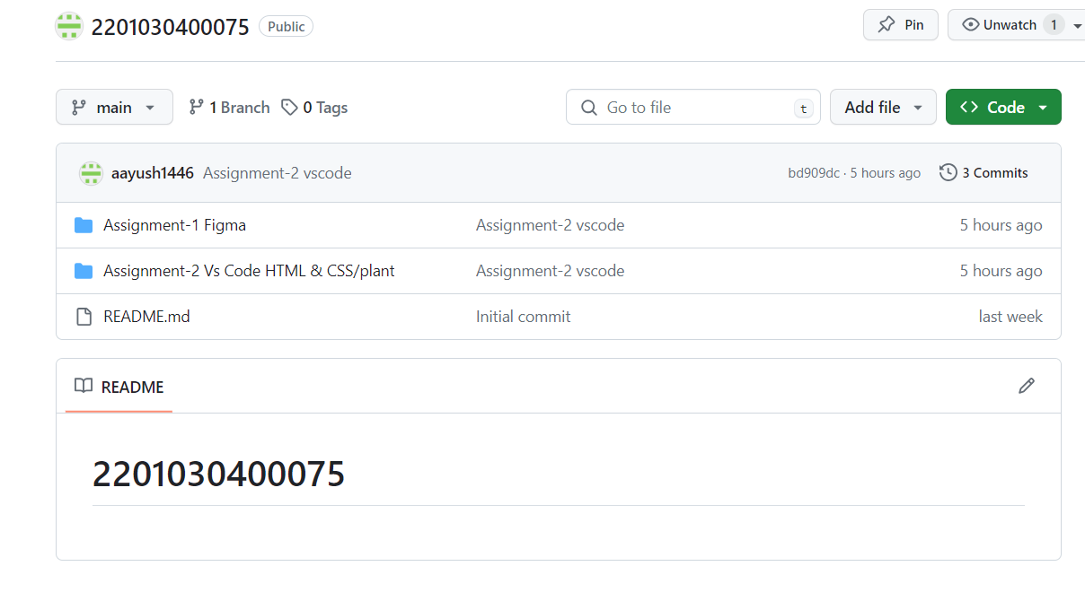

Created Assignment-1 & assignment 2 folders and uploaded data.